Chapter 19
Plant Defenses

Introduction

Most plants are sessile organisms affixed to an immobile substrate. Plants usually have the ability of movement, as occurs when a leaf tracks the movement of the sun through the day (phototropism) or a root orients its growth downward (gravitropism). However, such movements are insufficient to evade predators or pathogens. Instead plants rely on a variety of other mechanisms to prevent and reduce herbivory and disease. Plant defenses begin first with physical structures. If these are overcome a litany of chemical protection provides a vast arsenal with which to mount counterattacks. While plant immune defenses are much different than animals, they do have reactive immune systems which share some of the same mechanisms as our own. We will discuss some of these features in this chapter, beginning with physical structures, then moving on to summarize chemical defenses and reactive plant immunity as they occur in pattern- and effector- triggered immunity (PTI and ETI) systemic acquired resistance (SAR) and induced systemic resistance (ISR)

Physical
All plants have cell walls that allow plants to remain erect and also act as a barrier of protection. However, this also means that plants are unable to move like animals do and thus cannot evade potential predators or pests. Therefore, plants have evolved other mechanisms for defending themselves including physical defenses, chemical defenses, and immune systems which all serve to protect the plant and increase its overall fitness.
The first line of defense plants have against pathogens, similar to ourselves, is a physical barrier. Both woody plants and humans have a layer of dead tissue that is constantly produced and sloughed off; among plants it is their bark, among humans it is our skin. The protection of the internal body within is an important purpose of bark and skin. On plant parts that do not develop bark, there are still protective layers of epidermis, such as leaves, coated with waxy cuticle to act as protection against abiotic and biotic stressors.

Table 19.1. Trichome types found on Cannabis
Type |  | Approximate sizes | Features
Non-glandular | Non-cystolithic | 70-125 μm | Thin, unbranched, simple in shape. Unicellular. Occur most densely on the underside of leaves and bracts.
 | Cystolithic | 250-370μm | Similar to non-cystolithic in shape, but larger. Contains cystoliths, calcified outgrowths of the cell wall, at their base.
Glandular | Bulbous | 10-30 μm | Diminutive trichome with secretory cells. Variable structure.
 | Capitate sessile | 25-100 μm | Large glandular head with secretory cells often attached by several cells, but only one cell high.
 | Capitate-stalked | 70-150 μm, stalk up to 1000 μm | Large glandular head with secretory cells situated on top of a slender, multicellular stalk.
 | Antherial Sessil | 25-100 μm | Occur only on the anthers and calyx of male flowers.

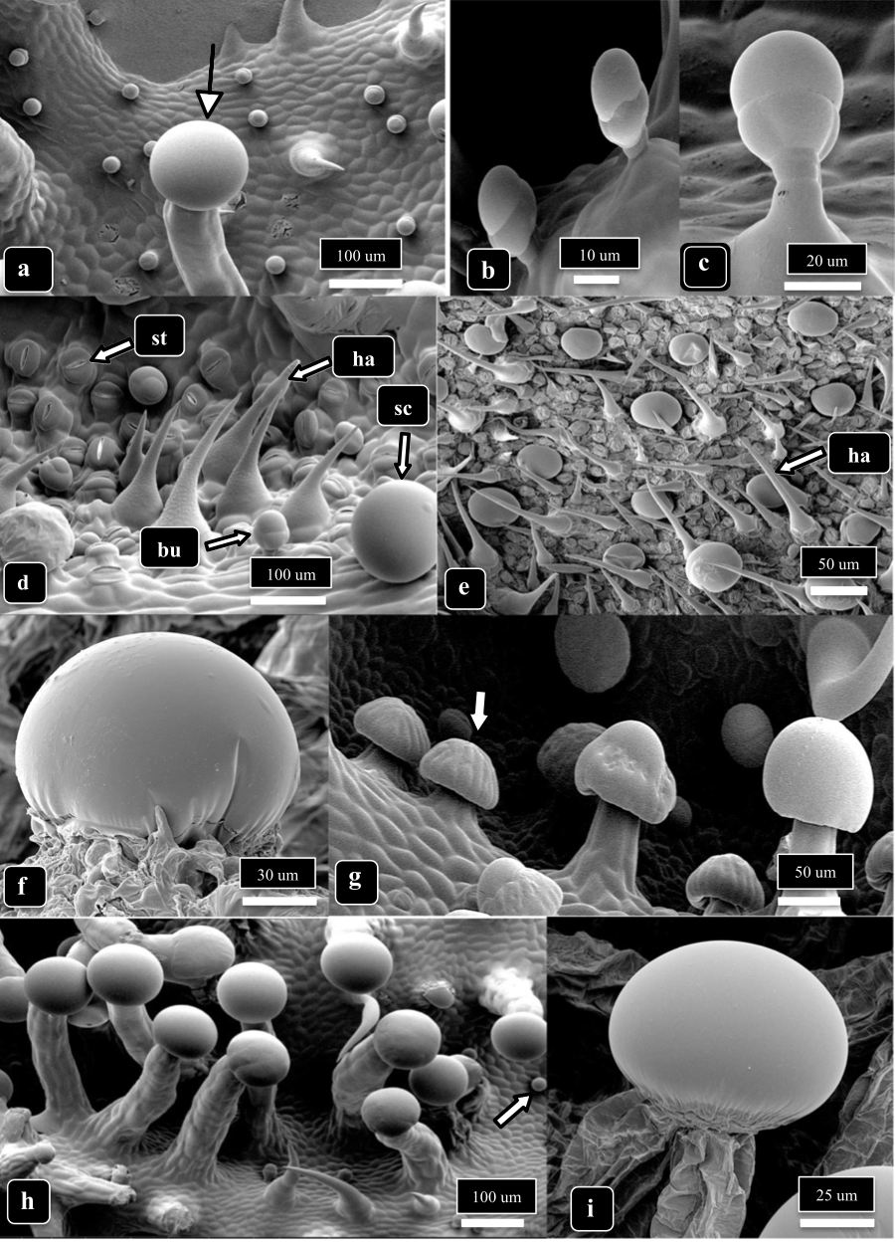
Fig 1. Scanning Electron Micrograph (SEM) showing different types of trichomes Cannabis plants can produce. The arrow in a) is pointing to a stalked capitate trichome, b) & c) are showing bulbous trichomes, images d) & e) show bulbous (bu) non-glandular (ha) and sessile capitate (sc) trichomes as well as leaf stomata (st), f) is a zoomed-in image of a sessile-capitate trichome, the arrow in g) is pointing to a presecretory sessile capitate trichome with stalked-capitate trichomes to the right, the arrow in image h) points to a small bulbous trichome and stalked-capitate trichomes to the left, and image i) is a close up of the head of a stalked-capitate trichome. From Punja et al 2023.

Many plants also possess trichomes, for which Cannabis is especially famous (Table 1) (Fig 1). Trichomes may serve myriad roles: increasing the boundary (humidity) layer near the leaf, shading leaves from intense light, physically detering herbivory, and secreting defensive chemicals. Cannabis plant produce at least three types of trichomes that contain cannabinoids and terpenes, acids, and polyphenols. Types and sizes of trichomes vary with genotype and age of plant (Fig 1).
Each plant cell also possesses a selectively permeable plasma membrane contained within a cell wall composed of lignin, cellulose, and xylan. Roots have a specialized internal barrier, the Casparian strip, that forces incoming water through to enter the symplast and pass through the plasma membrane of cells before entering the vascular tissue for transport throughout the rest of the plant body. The apoplast refers to water transport in between cells, whereas the symplast refers to water transport among cells after entering through the plasma membrane. Forcing water through the plasma membrane of cells allows the cell to exclude large molecules and organisms, unless there are specific transport channels and proteins that permit their entrance.
One of the most susceptible areas of an undamaged plant body to infection are the stomata. Stomata are openings that allow the exchange of gas. Necessarily, these openings are physically at high risk of exploitation by organisms (pathogens, commensals, and mutualists) that grow inside plants. Often fungi will form an appressorium directly on top of a stoma, permitting easier access by pushing between the two guard cells, rather than breaking a new opening through the leaf cuticle and epidermis (Fig. 3). Root-hairs are also often targeted by microbes as a means of entry.

Chemical

Plants produce a variety of chemicals directly effective against pathogen attack, called secondary metabolites, a catch-all term for any molecule produced by a plant not directly involved in the primary metabolism of a plant. These may include terpenes, phenolics, alkaloids, phytoalexins, defensins, enzymes, among others. Many secondary metabolites are important for plant health and survival by mediating microbial interactions and defending the plant against microbial or animal attack.
Secondary metabolites that are produced or activated only after contact with a pathogen are called phytoalexins. Though sometimes this term is broadened to include all plant defense chemicals, defense chemicals present pre-infection are not true phytoalexins. Recent attempts to categorize the immense variety of phytoalexins and plant defense chemicals are summarized in Table 19.2.

Table 19.2. Chemical defenses of plants involved in microbial defenses.

Non-Nitrogen Containing | Terpenes/Terpenoids  Flavonoids  Lignans  Phenylpropanoids  Coumarins  Tannins  Steroids  Saponins  Polyacetylenes  Fatty acids
Nitrogen Containing | Alkaloids  Non-protein amino acids  Amines  Alkamides  Lectins  Peptides  Polypeptides  Enzymes  Defensins  Small interfering RNAs  Nucleic acid extracellular traps

Plant Immunity

Plants lack an adaptive immune response like those found in animals. However, plants are not helpless. They have innate abilities to respond to pest and pathogen attack by changing aspects of their physical growth and the production and distribution of their protective chemical arsenal. Following a trigger, plants are able to “induce” a whole plant immune response.
Depending on the nature of the trigger and subsequent signaling pathway (jasmonate or salicylate, respectively) such an induced state is called induced systemic resistance (ISR) or systemic acquired resistance (SAR) (Wang et al., 2004). Both ISR and SAR prime the immune responses of the entire plant, but ISR is a milder response than SAR. ISR is often triggered by interactions with symbiotic microbes, such as Rhizobia or mycorrhizae, whereas SAR is more often a response to pathogenic attack. Through ISR and SAR plants recognize foreign invaders via pattern triggered immunity (PTI) and effector triggered immunity (ETI) (See Table 3 for list of abbreviations).
Table 19.3. Abbreviations of commonly encountered terms when discussing plant immune responses.

ISR | Induced Systemic Resistance
SAR | Systemic Acquired Resistance
PTI | Pattern Triggered Immunity (aka Basal Immunity)
ETI | Effector Triggered Immunity
MAMPs | Microbe-Associated Molecular Patterns
DAMPs | Damage-Associated Molecular Patterns
NAMPs | Nematode-Associated Molecular Patterns
PAMPS | Pathogen-Associated Molecular Patterns
PGPR | Plant Growth Promoting Rhizobacteria
PR-proteins | Pathogenesis-Related proteins
ROS | Reactive Oxygen Species
R-genes | Resistance genes involved in ETI, most often of the nucleotide binding, leucine rich repeat (NB-LRR) or pattern recognition receptor protein (PRR) classes

Pattern triggered immunity (PTI) (aka basal immunity):

Pattern triggered immunity in plants is an evolved sensitivity to microbe-associated molecular patterns (MAMPs) and damage-associated molecular patterns (DAMPs). MAMPs are often fundamental, conserved portions of the microbial pathogen, such as essential cell wall or membrane components (i.e. lipopolysaccharide in bacteria and chitin in fungi) which cannot be altered by single gene mutations in the microbe genome. DAMPs, on the other hand, represent damaged cell machinery of the host plant itself (i.e. cell wall fragments, damaged proteins, DNA and RNA fragments). DAMPs recognition is more indirect than MAMPs. DAMPs are not under the control of the pathogen genes; they result from inevitable damage which occurs during pathogenic invasion of a host plant.
Effector triggered immunity (ETI):

Effector triggered immunity describes a concept that has been historically referred to as the gene-for-gene relationship. The gene-for-gene relationship is in many ways a road map (or perhaps more appropriately a treadmill) through the evolutionary history between a host and pathogen. For each gene that enables a pathogen to cause disease, there may be a corresponding gene among the host species that counteracts the gene in the pathogen and permits plant resistance. Many of the pathogen genes which enable virulence code for metabolites called effectors (proteins), which act on the machinery (proteins) of the host plant (Fig. 4).

Each time a gene that confers virulence to the pathogen emerges, a selective pressure is exerted on the plant host population (natural selection). Susceptible plants are either killed or diminished in their ability to reproduce; if there are some individual plants with some form of genetic resistance they will survive and reproduce more prolifically. As a result, genes for resistance become more common (are ‘naturally selected’) in the population's gene pool. This neutralizes the ability of the pathogen variety, or race, to cause disease among most plants in the population; until and unless a genetic mutation arises which somehow permits the pathogen to evade the newly common gene of plant immunity, which has now spread through the host population. When this type of evolutionary interaction occurs, a single gene in the pathogen, which would allow it to act virulently in a susceptible plant host, corresponds to a single gene in a resistant host plant which neutralizes its action; hence the term ‘gene-for-gene.’
A zig-zag model is often used to interpret the interplay of PTI and ETI. PTI is triggered by nearly all microbial invasions (Fig. 5). Some microbes have evolved effectors which act against PTI to permit their persistence in the plant host. If the plant host is resistant, it has R-genes to respond to the microbial effectors, neutralizing them. Microbes may evolve new, or variations of, effectors to sidestep the host plant R-genes, thus carrying on a never ending arms race.

Figure 19.2 Zig zag model of plant immunity (adapted from Jones and Dangl 2006).

Because such a diverse group of molecules are able to trigger immune responses, and the type of plant response based on the trigger molecule is not always consistent with the zig-zag model, the “danger model” has been proposed with the term “danger signal” denoting all molecular triggers of plant immunity. Rather than classifying the immune response as simply PTI or ETI, it as been suggested that plant immune responses may be divided as either intracellular or extracellular, in what is called the “spatial immunity model.”
Plant genes conferring vertical resistance are mostly among the R-genes involved in ETI in a gene-for-gene fashion. Two major classes of R-genes are genes that code for nucleotide binding site-leucine rich repeat (NBS-LRR) proteins or pattern recognition receptor (PRR) proteins. Some families of proteins recognizing effectors found in plants have analogues among animals. The similarity in structure and function of these protein families is most likely the result of convergent evolution, rather than divergence from a protein present in a common ancestor of plants and mammals (Ausubel, 2005). However, the similarity is striking. If these protein families are related through descent from a common ancestor, these are in fact homologous proteins rather than unrelated analogs.

Systemic acquired resistance (SAR) and induced systemic resistance (ISR):
Both ETI and PTI are able to increase the subsequent ability of a plant to respond to pathogen attack. Depending on how the plants defenses are activated, different pathways are set in motion to increase plant resistance. Induced systemic resistance (ISR) generally occurs when PTI is activated and is mediated largely by plant hormones jasmonate and ethylene, whereas ETI is associated with the plant response, systemic acquired resistance (SAR), and is mediated primarily by salicylic acid activity (Table 4).

Table 19.4. Features of SAR and ISR
Systemic acquired resistance | Induced systemic resistance
- Triggered by biotic and abiotic stressors (MAMPs/DAMPs/Abiotic)  - Hypersensitive response- Localized Reactive oxygen species (ROS) burst causes host cell death around area of infection  - Pathogenesis-related proteins (PR-proteins) accumulate  - Callose production | - Salicylic acid ‘independent’  - Mediated by jasmonate/ethylene signal transduction  - Triggered by biotic inducers (MAMPs)  - Callose production

The induced immune responses among plants are not at all similar to the adaptive immunity of animals, which have antibody producing B-cells capable of producing novel antibodies and adding efficacious antibodies to their repertoire. Rather ISR and SAR activate and upregulate a variety of innate immune responses of which the host plant is capable. Plants in which ISR or SAR has been activated are more resistant to subsequent pathogen or pest attack throughout the entire plant body.
ISR can be induced by plant growth promoting rhizobacteria (PGPR), and was in fact discovered in systems researching these rhizobacteria (van loon et al. 1998). The phenotypic effect of SAR and ISR are similar in that disease occurrence and severity may be reduced. However, these pathways are activated under different conditions, by different signaling pathways, and result in different effects (though there is significant crosstalk among salicylic acid, jasmonate, and ethylene in both systems)
SAR for instance is characterized by the production of pathogenesis related proteins (PR-proteins) and the hypersensitive response. PR-proteins are a diverse group of proteins involved in plant defense (including as enzymes and defensins) that are not produced following ISR activation. The hypersensitive response refers to localized host cell death (apoptosis) induced by a burst of toxic reactive oxygen species (ROS) in cells surrounding the diseased portion of the plant. At the same time, there are also directly overlapping effects of ISR and SAR, such as the production of callose, a beta-glucan, that among other roles, serves to modulate the permeability of plasmodesmata. Following ISR and SAR activation, callose is produced to strengthen cell walls and limit pathogen dispersal within the plant.
Due to how plants evolved mechanisms for defending themselves against abiotic and biological damage, breeders can manipulate the genotype of plants and through traditional breeding techniques can develop genetic pools that are better equipped with chemical or physical tool to increase their chance of survival.

In summary:

- Plants have evolved defense strategies to protect themselves from potential pathogens including physical and chemical mechanisms
- Plant immune system includes Induced Systemic Resistance (ISR) and Systemic Acquired Resistance (SAR)
- Depending on what triggers the plant immune response the plant may produce chemicals intracellularly or extracellularly
- Immune response increase the plants ability to defend itself against pathogens

